Intuition

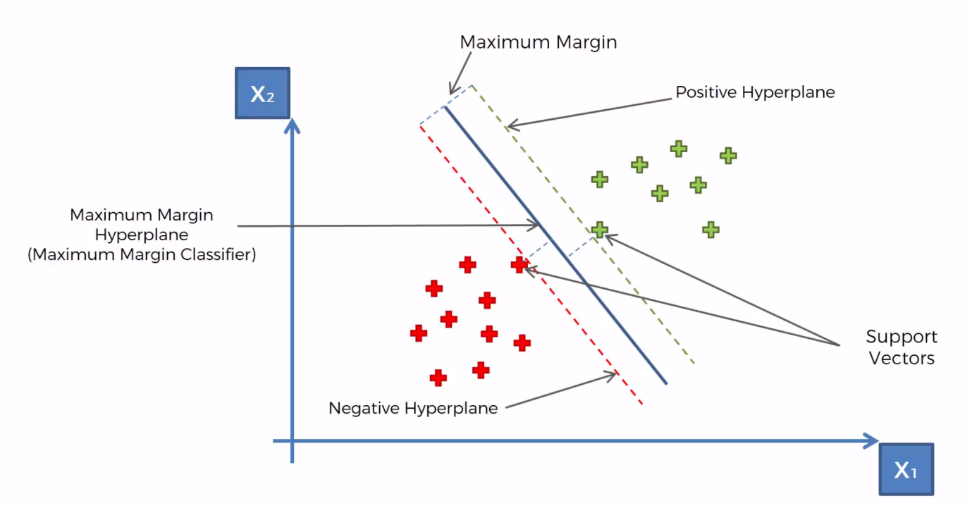Line surged through Maximum Margin

Supporting Vectors, the one supporting the decision boundary.

Maximum Margin Hyperplane (Maximum Margin Classifier)

Positive hyperplane, Negative hyperplane

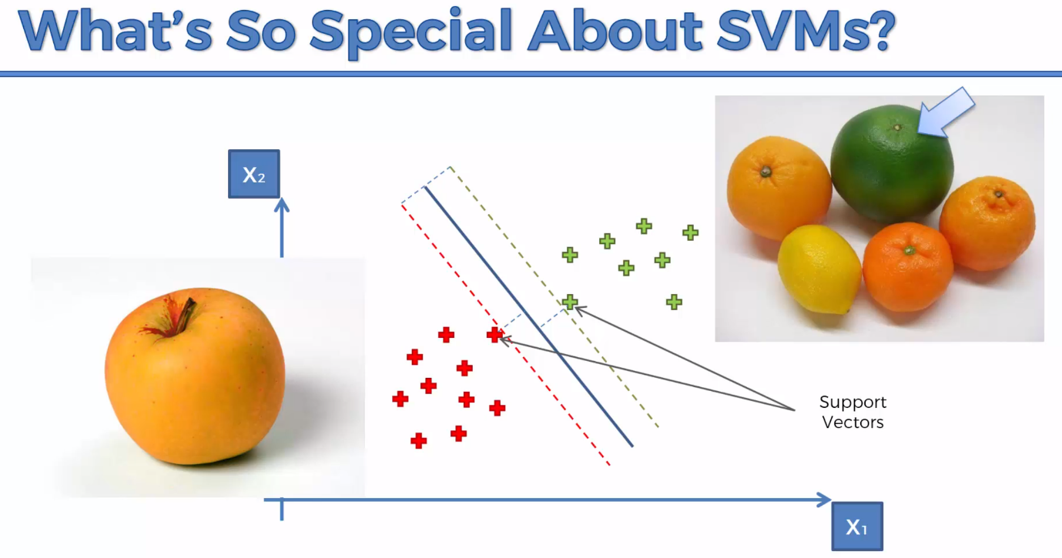Teach a machine, Apples vs Oranges. Special Feature Classification